LAPORAN DOKUMENTASI

NAMA: SUHARNINA AKSAN
NIM: IK24110001

SCRENSHOOT GAMBAR 1
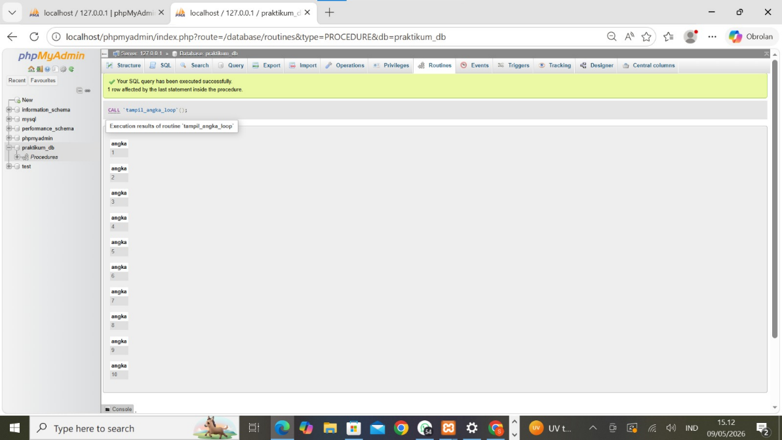

SCRENSHOOT GAMBAR 2
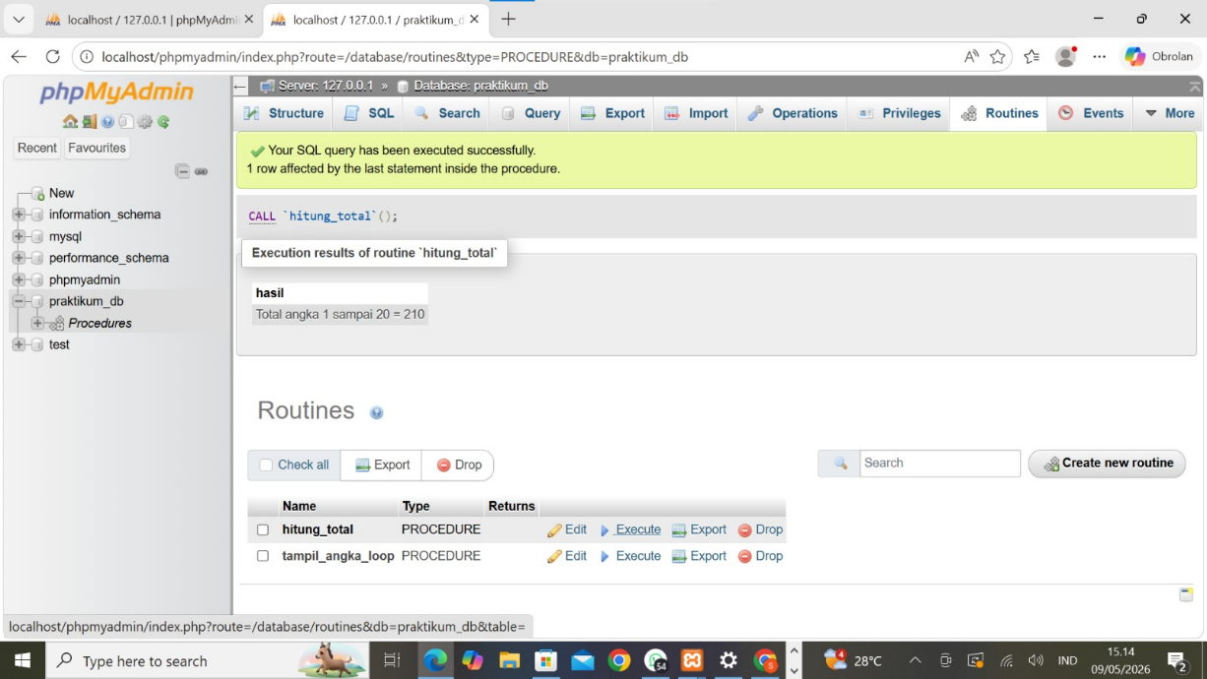
SCRENSHOOT GAMABAR 3
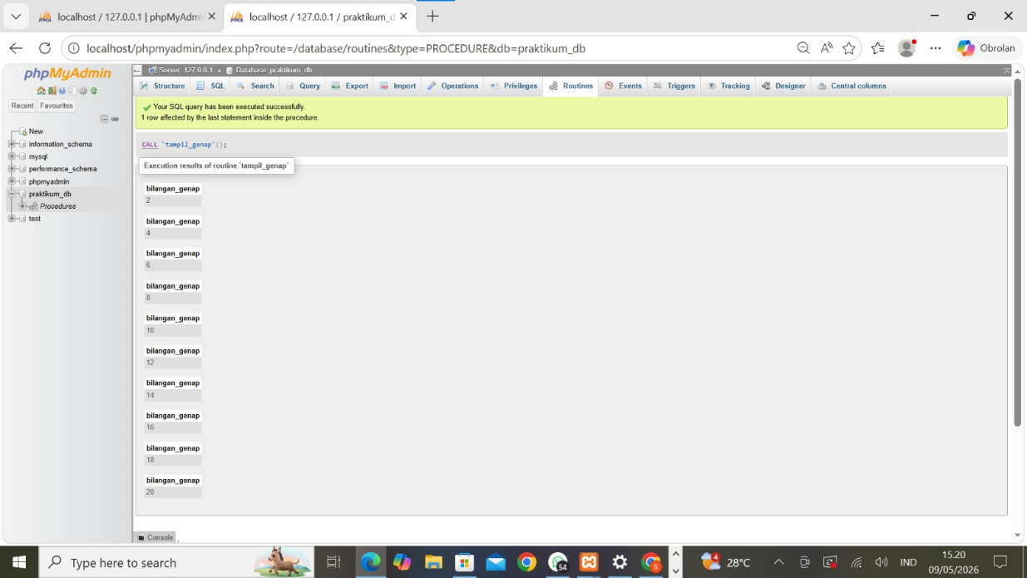

SCRENSHOOT GAMBAR 4
